**Kirk of Holly Springs Missions Calendar for 2018**

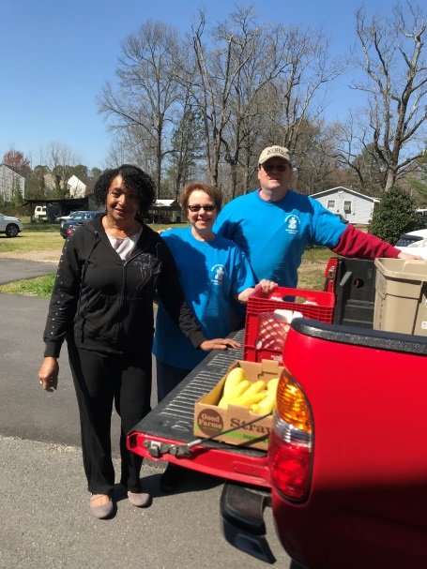 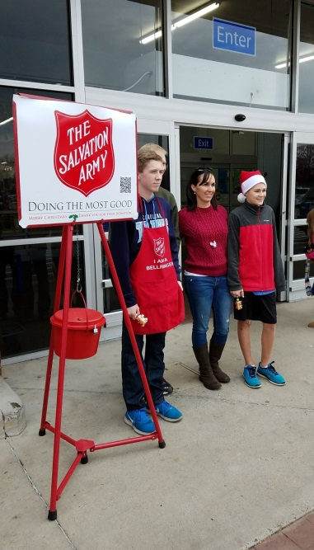 

**Weekly Food Panty Assistance Salvation Army Bell Ringing Habitat for Humanity Work Day**

**Monthly**

Collect Pennies for Hunger (First Sunday)

Do Minute for Mission (First Sunday)

Collect Brown Bag Bring Back/Food Pantry Donations

Assist with Holly Springs Cupboard Food Collection (Thursday of Each Week) and Bi-Weekly

Fruit Pick Up

Carry Out Card Ministry for Kirk of Holly Springs Members and Regular Visitors

Hold Missions Committee Meeting (2nd Tuesday of each month at 7 p.m.)

**January**

Do Letter to Former Guatemala Scholarship Student

Take Toiletries to Helen Wright Center Residents

**February**

Participate in Local Habitat for Humanity Build (February 24)

**March**

Provide Lunch for Habitat for Humanity Build (March 3)

Hold March Madness Food Drive

Collect One Great Hour of Sharing Offering

**April**

Provide Social for Residents of Holly Springs Manor Senior Apartments (April 10)

Assist with Family Promise for Homeless Families at Kirk of Kildaire (April 22-28)

**May**

Coordinate Rise Against Hunger Event

Participate in Relay for Life Activities

Participate in Habitat House Dedication

**June**

Do Mid-Year Donations

Attend Ramadan Meal with Kirk of Kildaire Members

Help with Compassion Day at Holly Springs United Church of Christ

**July**

Do Letter to Former Guatemala Scholarship Student

**August**

Collect School Supplies and Distribute at Holly Springs Food Cupboard

**September**

Collect Disaster Assistance Offering

Provide Dinner at Helen Wright Center for Homeless Women

**October**

Collect Undies and Socks for Foster Children and Children Seen at Department of Social Services

Have Booth at HollyFest Community Festival

Develop Missions Budget for 2018

**November**

Do End-of-Year Donations

Support Holly Springs Manor Senior Apartments Thanksgiving Event

Collect Donations for Thanksgiving Meals Offered Through Fuquay-Varina Food Pantry

Collect Offering for Habitat for Humanity Community Build at Joint Thanksgiving Service

with Holly Springs United Church of Christ

**December**

Participate in Rise Against Hunger Event at Kirk of Kildaire

Participate in Holly Springs Salvation Army Bell Ringing

Assist with Family Promise for Homeless Families at Kirk or Kildaire

Participate in Holly Springs Christmas Parade

Collect Joy Gift Offering

Distribute Poinsettias to Sick, Shut-in, and Widows

Participate in Angel Tree Gift Collection

***Let each of you look not only to his own interests, but also to the interests of others. Philippians 2:4***